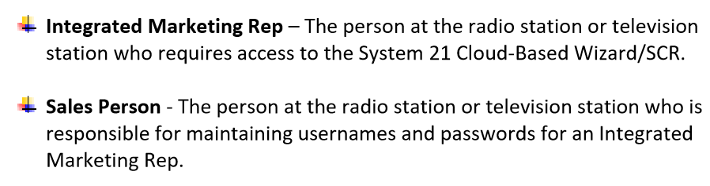

Please replace (above) “Integrated Marketing Rep” “Integrated Marketing Consultant” and replace “Sales Person” with “Sales Manager”…and anywhere else where there is a reference to these positions.

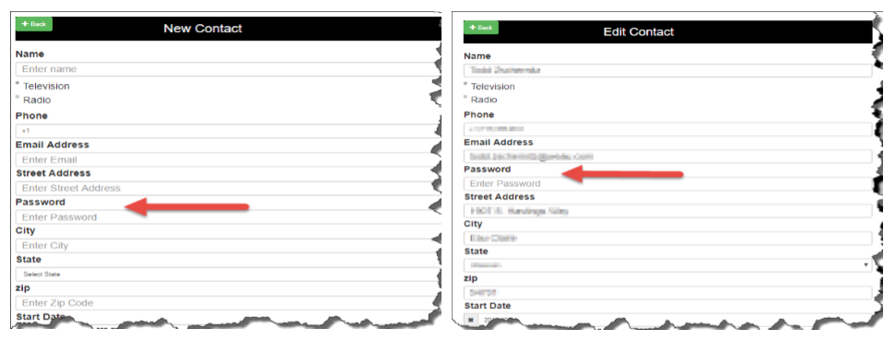

Please change “City” to “Market” and delete “Street Address” and “Zip” and replace with only with “Ownership.” We will keep “State”

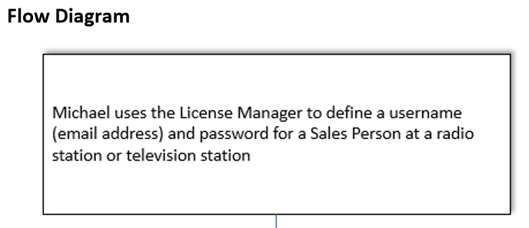

Please replace “Sales Person” with “Sales Manager” above.

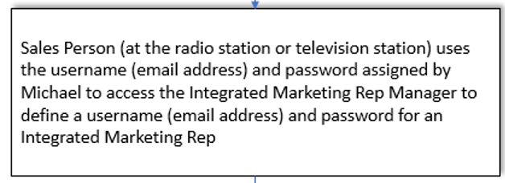

Please replace “Sales Person” with “Sales Manager” above and “Integrated Marketing Rep” with “Integrated Marketing Consultant”

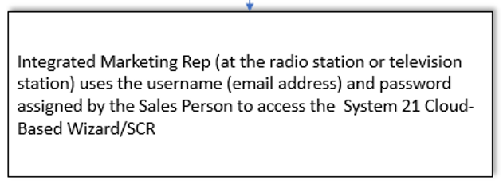

Please replace “Sales Person” with “Sales Manager” above and “Integrated Marketing Rep” with “Integrated Marketing Consultant”

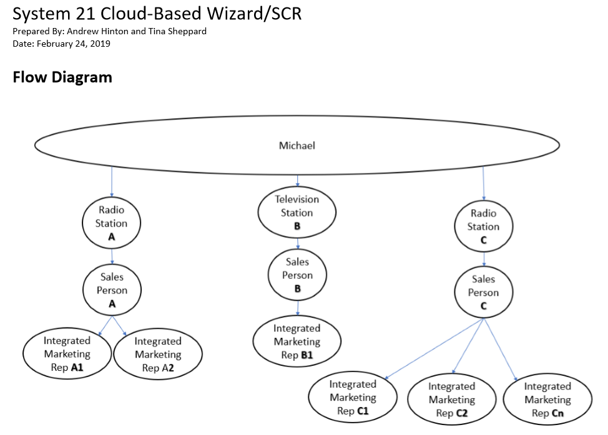

Please replace “Sales Person” with “Sales Manager” above and “Integrated Marketing Rep” with “Integrated Marketing Consultant”

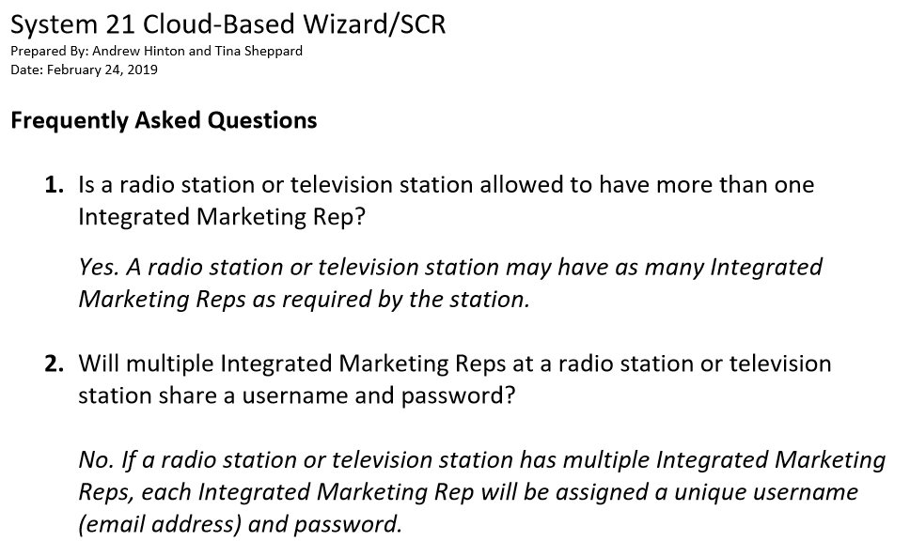

Please replace “Integrated Marketing Rep” with “Integrated Marketing Consultant”

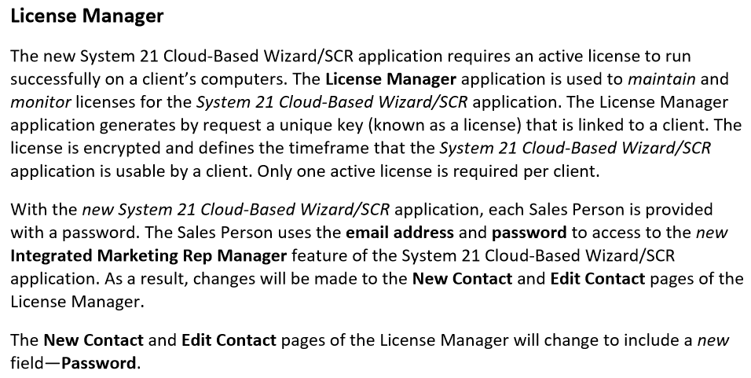

Please replace “Sales Person” with “Sales Manager” above and “Integrated Marketing Rep” with “Integrated Marketing Consultant”

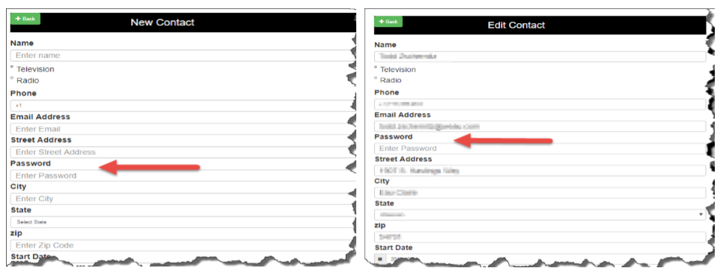

Please change “City” to “Market” and delete “Street Address” and “Zip” and replace with “Ownership.” We will keep “State”

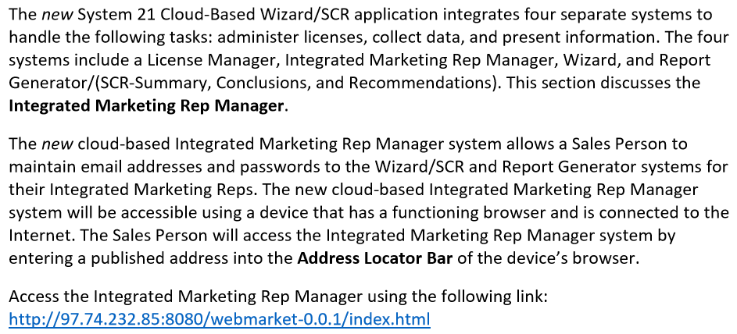

Please replace “Sales Person” with “Sales Manager” above and “Integrated Marketing Rep” with “Integrated Marketing Consultant”

I’m not sure if the above link is in testing phase, but I tried adding a new contact for Natalie Guld and it did not take. The first time I tried I mistakenly added her “name” in the “email” section and it prompted me that it was not a valid email so I tried to change it but would not delete the “Invalid Email format” message, so I started over and it still did not take when I clicked “Add Contact.” It still might be in the testing phase but just wanted to make sure.

Also wanted to confirm again that we could still use the licensing website for the PowerPoints (existing program) for those stations that prefer to still utilize this format and have not been disrupted by the Microsoft Office upgrade? I am assuming the cloud version would be a wholly separate licensing page? This would probably only be still utilized by stations the preferred to edit the PowerPoint once the SCR is created (i.e. customized backgrounds, delete text boxes or add info).

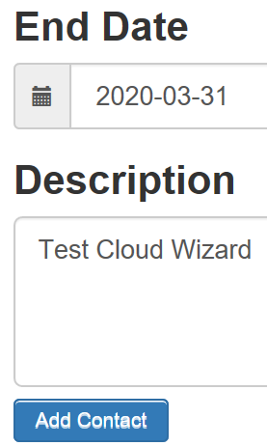

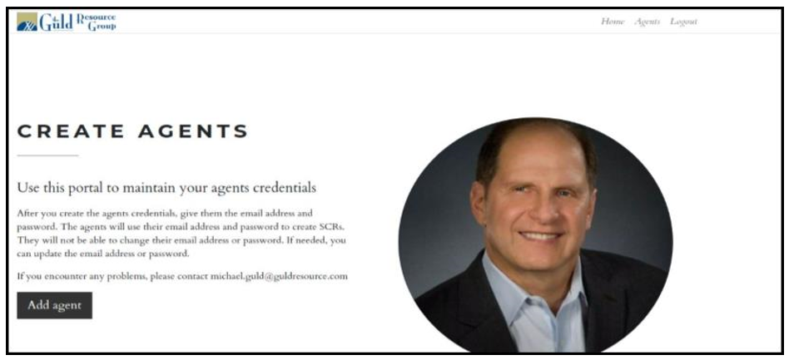

I believe that the “Create Agents” is actually “Integrated Marketing Consultants.” If so can we be consistent with the wording and use “Integrated Marketing Consultants” in place of “Create Agents”…using that term anywhere above where “Agents” or “Agent” is used?

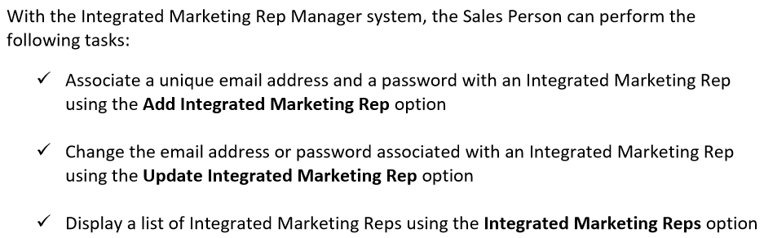

Please replace “Sales Person” with “Sales Manager” above and “Integrated Marketing Rep” with “Integrated Marketing Consultant”

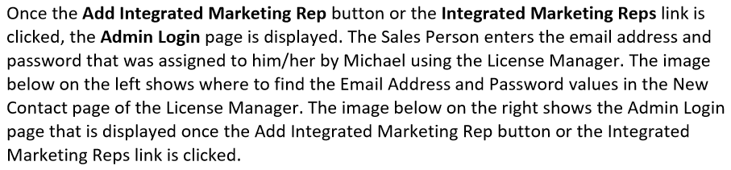

Please replace “Sales Person” with “Sales Manager” above and “Integrated Marketing Rep” with “Integrated Marketing Consultant”

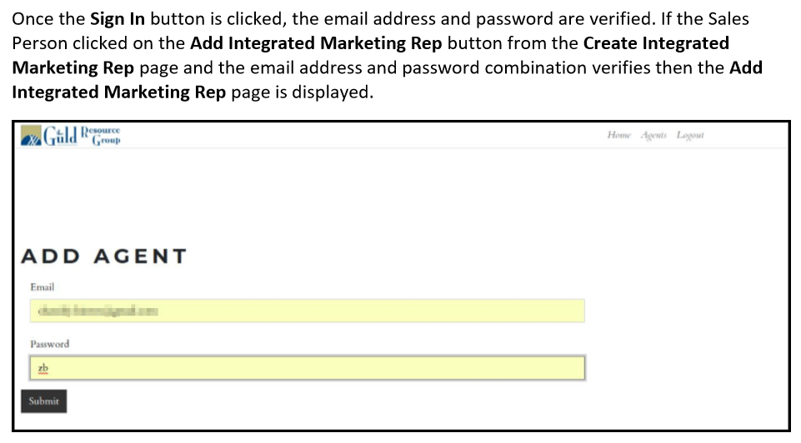

Please replace “Sales Person” with “Sales Manager” above and “Integrated Marketing Rep” with “Integrated Marketing Consultant.” In addition, please replace “Add Agent” with “Add “Integrated Marketing Consultant.” Lastly, please replace The Guld Resource Group Logo with the System 21 Logo.

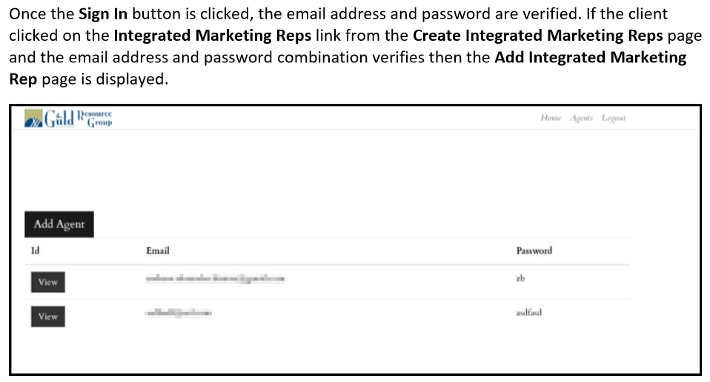

Please replace “Integrated Marketing Rep” with “Integrated Marketing Consultant.” In addition, please replace “Add Agent” with “Add “Integrated Marketing Consultant.” Lastly, please replace The Guld Resource Group Logo with the System 21 Logo.

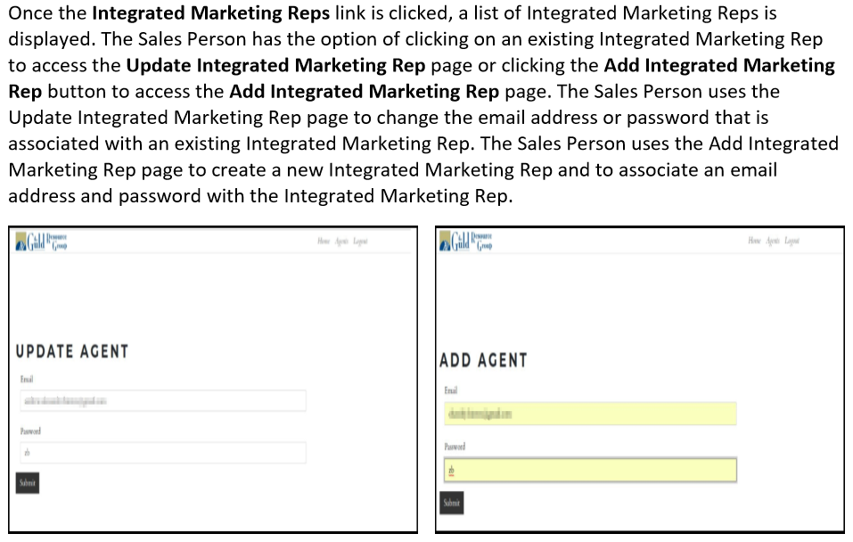

Please replace “Sales Person” with “Sales Manager” above and “Integrated Marketing Rep” with “Integrated Marketing Consultant.” In addition, please replace “Update Agent” and “Add Agent” with “Update Integrated Marketing Consultant.” and “Add Integrated Marketing Consultant.” Lastly, please replace The Guld Resource Group Logo with the System 21 Logo.

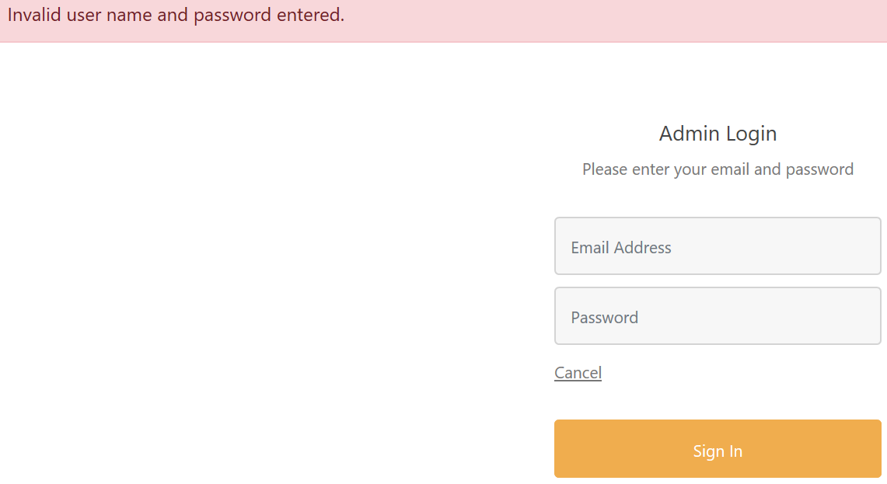

I am not sure if the above is activated yet or if I have to have already had approved credentials, but it did not work for me (see above “Invalid User”).